

ANNUAL REPORT 2013-2014

*“The REACH OUT TRUST has worked among the Adivasi (Warli Tribe) Communities*

*To banish worry, fear and strife.*

*To right some wrongs and change paths*

*And bring joy and hope into their life.”*

The Trust has been working in the Talasari Taluka150 k.m North of Mumbai in these last many years. The main efforts have been to upgrade performance in the fields of education, skill training, women empowerment, health care and environment.

**EDUCATION:**

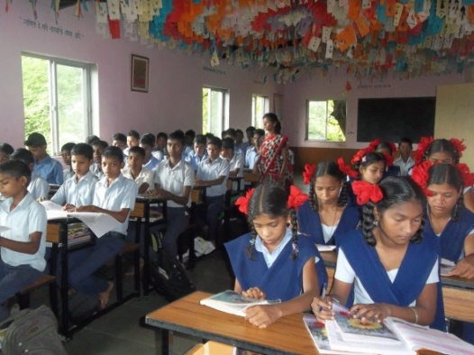Our School, Pushpa Vidyalaya (school with flowers), a Primary, Middle and High school in Marathi, has now been recognized by government. However, it is un-aided by Government. We therefore have to seek help from organizations and individuals for payments of salaries of teachers and for furniture and maintenance of the school. We will need more classrooms, also space for library, laboratory and offices. In this almost 100% Adivasi area with very low socioeconomic status, fees alone cannot sustain the running costs of the school. Jointly we must succeed so that these enthusiastic Adivasi children can get a good education and a bright future.

There is a dearth of schools, especially after the 7th Standard. Last year we got nearly 100 applications for the 8th Standard. We also had K.G., 1st and 2nd Standard and also 5th Standard, a total of almost 170 children. Most of the families (90%) were small farmers with 2 acres or less of land 8% of the families were land less. Most of the farmers grow a single crop of rice in the monsoons.

The students did well in academics, sports and cultural activities. Under the able guidance of our teachers they put up a wonderful performance on the occasion of the visit of our Sponsors, Drs. Barbara und Wolfgang Sietz from Germany in March 2014. Colorfully dressed, there were items of Warli dance, drills, songs and drama. The English Play of the tiny tots was much applauded by all. Finally the whole community of parents, teachers, students and guests, all were dancing to the tunes of the Warli beat of Tarpa (horn) and drums.

In the last few months we completed the construction of the wall around the open well and work on the underground water tank. The hand-pump of the bore well needed also repair. With all these efforts it should be easier to provide water supply to school children and to keep the school compound green in spite of the summer heat.

(1)

Admissions to the school have begun from May onward. Parents are being informed that very moderate school fees will have to be paid. We will have additional teachers, new furniture and equipment for additional classes. We also provide some medical facilities for the students, including treatment of 2 cases of Hansen’s disease (Leprosy) and prevention of rabies in 2 children bitten by a rabid dog. Nutrition supplements in the form of fruits and cereals are provided in the morning as most of the students are very underweight for their age seen from the weight scored.

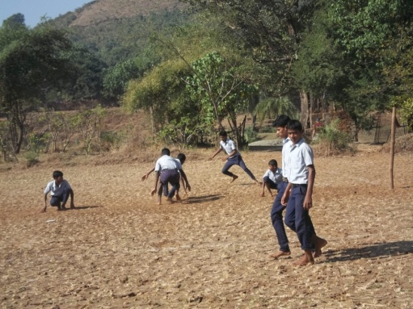We have an active Parent Teachers Group. In the month of May Reach out Trustees, Fr. Andrew, Dayanand Dabolkar, Sr. Marie, Ancilla and Adolf Tragler, held a meeting with Teachers, Management and Parents. Parents agreed to pay a nominal fee of Rs.100/- per month. This is a very meager amount compared to the fees in other private schools. This meeting provided a measure of community participation. After all: this is their village school.

Dr. Barbara Sietz has promised to provide scholarships for poor children. Anil Moda and Santosh Megwale continue to play an active role in the Management of the school, together with Urmila,Kankad the headmistress of the school, a very skillful lady who is also to be congratulated on her recent marriage. By the end of June (2014) 220 children had enrolled for standards 1st ,2nd 5th, 6th 8th 9th in our Marathi students.

**VOCATIONAL SKILL TRAINING:**

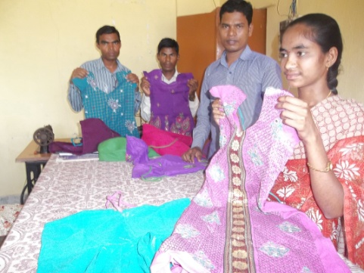Our Training Courses in Tailoring, Welding and Computers continue with good results. About 70 youths completed their 6 months training courses in the last year. Our social worker Pritesh Bhosle and our technical Co-coordinator, Sunil Corriea, are kept busy throughout the year with recruitment, training and job placements. We proudly announce almost 100% job or self employment of our trainees. For this we are co-coordinating with industries in the commercial belt, especially fashion designing and technical industries for job placement. Women manage to be self-employed, tailoring for their own families and for others.

We also co-ordinate with skill training opportunities offered by government. With the help of the local block development officer we were able to send a few youths for training to become drivers and motor mechanics in the last year.

With government elections completed, we are hoping for more schemes from Government for the benefit of adivasi families. These families need help in procuring documents like ration cards, caste certificates etc. without which they cannot get the benefits of government schemes. With such help from our side recently 2 families could secure government assistance for construction of their homes (free building materials).

Some students also visit our centre for tuitions and help in their school work. Beside we held a short leadership training program for youth. We plan to initiate English conversation classes soon.

(2)

**WOMEN AND HEALTH:**



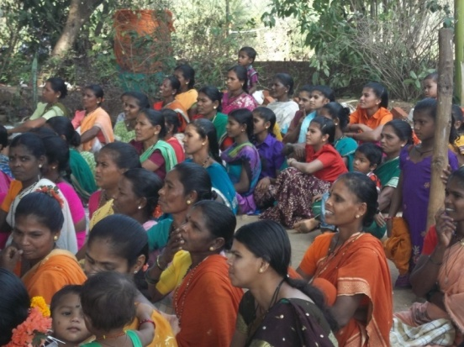Saving schemes for women continue, now mostly self managed. In August we held and eye and general check-up camp in collaboration with the NGO Bhakti Vidyanta. About 100 women came for the check up. 10 women were referred for cataract operation. We also assist some T.B patients in treatment. Many of local women leaders whom we had trained as health workers, have now been enlisted in the government ‘ASHA’ scheme. These ASHA members have to take care of health and social needs at the door steps of Adivasi homes. They regularly refer patients and pregnant women to the government medical centres.

Though morbidity has decreased, infections, diseases like hepatitis, pneumonia and diarrhea still take their toll. But children and women are better in health and small family norms are being accepted more readily by the younger generation. Children are still underweight in spite of government nutrition supplementation. Alcoholism is problem among male adults.

**TRUST LAND AND ENVIRONMENT IMPROVEMENT:**



Supply of electricity is still a great problem in rural areas. Our Pushpa Vidyalaya School and the homes in Dhangadpad have no electricity supply at all. Other Villages and Padas have interrupted supply with long gaps in between. We are working with a youth group to organize the people in Dhangadpada to make necessary down payments and apply for electricity supply. In a few villages we have helped to improve availability of drinking water. More needs to be done. Government is again promoting toilet construction by supplying some materials free of cost.

Milk production has not been successful mainly due to unskilled and unreliable labour. We must make it successful or close it down. Adivasi people are not milk drinkers. They keep cattle mainly for manure and bulls for ploughing of their rice fields. This makes it more challenging. In a land that was barren, we have made a green heaven. The teak trees on our land are growing to maturity and have become a financial asset for the Trust and we are into the sale of these trees. This has been one of the sustainable aspects of the project. On the Trust land the dairy scheme has been beneficial by providing organic manure for fruit trees like chikoo and coconut trees. In spite of erratic water supply, our chikoo trees are yielding good crops. Mangoes and bananas were less successful. We are also growing some green fodder for our dairy unit.

Reach out Trust, through its integrated approach, plans to further improve the future of the Adivasi people in Talasari and give them a possibility for a better tomorrow.

(3)

***SPECIAL THANKS TO***

We give thanks to all our well wishers and donors for their interest and donations to our Projects. Without your support these projects would not have succeeded.

Our appreciation and gratitude also goes to our family members and friends. Special thanks to:

Drs. Wolfgang & Barbara Sietz (Germany),

Dr. Christa Merkes Frei (Australia),

Mrs. Regine Proebsting & Gaby and Willem Lefeber & team (Germany),

Ms. Sabine Leschner and Altrernaid Stiftung fuer Menschen in Not (Germany),

S. N. Iyer Q. C. & Irene Iyer Charity Trust (Mumbai, India)

We are also thankful for the timely assistance of Sophia Polytechnic Mumbai.

We are very grateful to our Trustee Dr. Christa Merkes Frei who does the German translation every year. We also appreciate the assistance of Mr. Rajgopal and Mrs. Effie Acharya and Sr. Marie Noronha and Fr Andrew. Our special thanks to Mrs. Hannelore Huethmayr, and members of Helfende Hand (Austria). Bouquets also to the generous contribution of Dr. Helga Lohmann (Germany) and Herr Fritz Fuhrer Sabzburg, Family Strassmayr, Families Kronberger and Innerwinkler Families Tragler and Missionskreis Pettenbach Austria for their kind assistance.

**TRUSTEES:**

1. Mr. Joseph Keve, MSW, Chairman-Reach Out Trust, Palghar
2. Mr. Adolf Tragler, MSW, Secretary-Reach Out Trust, Director SRS Bandra Mumbai
3. Sr. Marie Noronha, M.ED, Education Specialist, Pune
4. Fr. Andrew Rodrigues, Director Social Action, Gagangoan, Talasari
5. Mr. Dayanand Ambolkar, MSW, Talasari
6. Dr. Mrs. Ancilla Tragler, MD, Coordinator- Reach Out Trust, Community Health Consultant Pediatrician Holy Family Hospital Bandra, Mumbai
7. Mrs. Anandini Thakoor, Social Activist, Mumbai
8. Dr. Christa Merkes Frei, Ex- Language Director, Max Mueller Bhavan, Mumbai
9. Dr. Irene Iyer, Social Activist, S.N. Iyer O.C & Dr Irene Iyer Trust, Mumbai

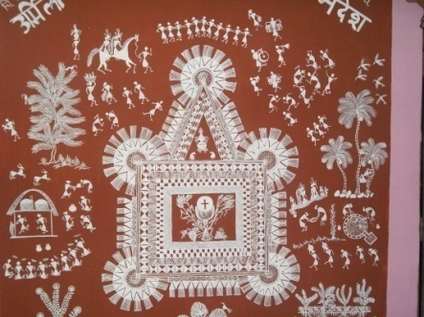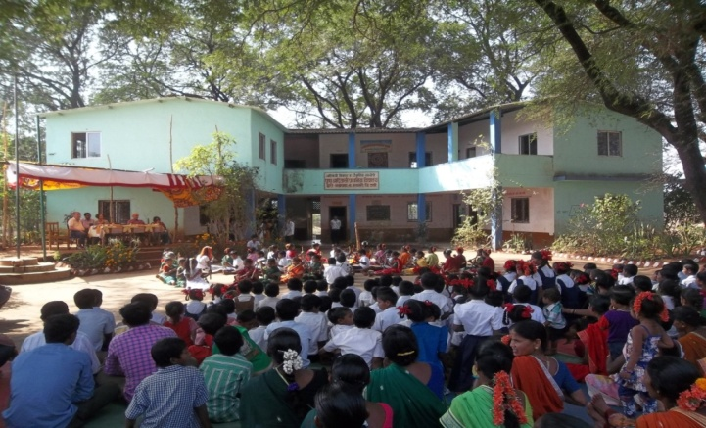

(4)

Donations for THE following SERVICES will be appreciated for the following:

|  |  |  |  |  |
| --- | --- | --- | --- | --- |
| 1 | Tailoring Vocational Courses | Rs.50,000/ | € 730/- | 6 months |
| 2 | School Teacher’s Salary | Rs.60,000/ | € 867/- | Per Year |
| 3 | Income Generation Project  (Small Scale) like Poultry | Rs.10,000/ | € 146/- | Per Unit |
| 4 | Children’s Uniform. | Rs. 500/- | € 70/- | Per Each Child |
| 5 | Warli Art Promotion | Rs. 500/- | € 70/- | For 2 small  paintings |

FOR Foreign Contributions:

|  |  |  |
| --- | --- | --- |
| Our Bank Name: | Indian Overseas Bank | |
| Address: | 36th Road, Radhasoami Apts, TPS III  Bandra(W), Mumbai – 400 050, India | |
| Account No. | SB 01280100001277 | |
| Swift Code No.  CONTACT:  REACH OUT TRUST  10, Samatadeep Bldg, Gr. Floor  25th Road, Bandra (W),  Mumbai -400 050, India  Tel/Fax No:0091-22-26455850  Email: [reachoutmumbai@gmail.com](mailto:reachoutmumbai@gmail.com)  Web Site : [www.reachoutmumbai.org](http://www.reachoutmumbai.org) | IOBA0000128  Reach Out Trust  Aruna, Dolarpada Post Girgaon  Talasari Dist. Thane – 401 606  Tel. 0091-7768092962 10, Samtadeep Bldg., | |
| Contact: | | Sparkonto |
| Hannelore Huethmayr | | Helfende Hand BOMBAY - Indian |
| Möhrergraben 3 | | Account No.20479 |
| A – 4643, Pettenbach | | Blz (bank – code) 34427 |
| Austria  Account No: 20479 | | Raiffeisen bank,  Austria blz (bank- code) 34427 |
| Email: huethmayr.hannelore@a1.net RAIFFEISEN BANK, A-4643 | |  |

|  |  |
| --- | --- |
| Reach Out Trust  Aruna, Dolarpada Post Girgaon  Talasari Dist. Thane – 401 606 Tel. 02521- 696508 | Dr. Ancilla Tragler,  Co-ordinator  E-mail: [atragler@gmail.com](mailto:atragler@gmail.com) Gr. Floor, 25th Road, |

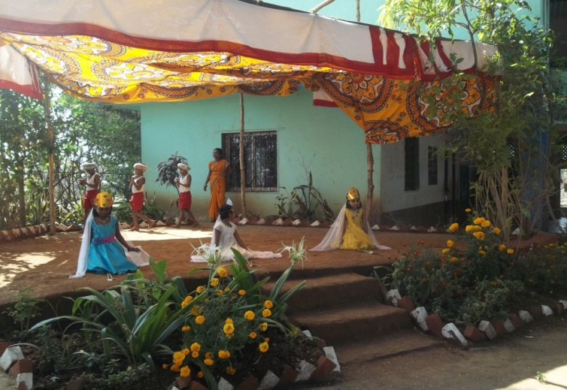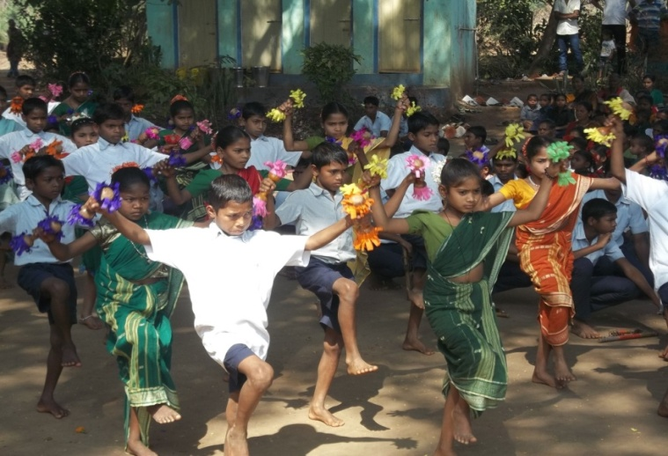

(5)